**What is Git**

**Git** is an **open-source distributed version control system**. It is designed to handle minor to major projects with high speed and efficiency. It is developed to co-ordinate the work among the developers. The version control allows us to track and work together with our team members at the same workspace.

Git is foundation of many services like **GitHub** and **GitLab**, but we can use Git without using any other Git services. Git can be used **privately** and **publicly**.

Git was created by **Linus Torvalds** in **2005** to develop Linux Kernel. It is also used as an important distributed version-control tool for **the DevOps**.

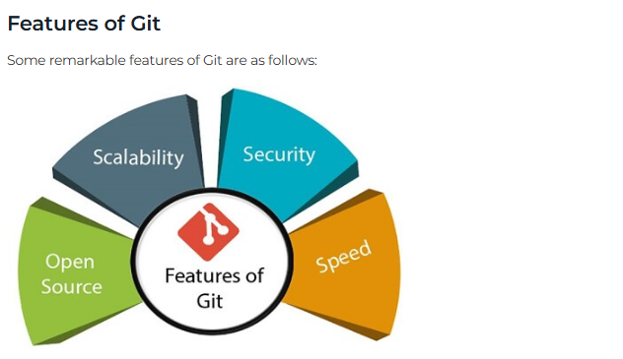

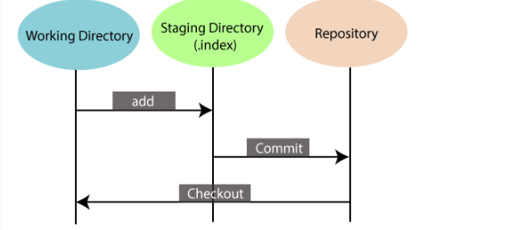

## Benefits of Git

## 

## 

